Q2)

PART A:

A 39-hp, 440V, Permanent Magnet Motor operates at 1000 rpm on full load. The motor efficiency is 86.72 %, and armature resistance is 0.337 ohm. (The motor is operating at steady state and the circuit schematic is illustrated at Figure X)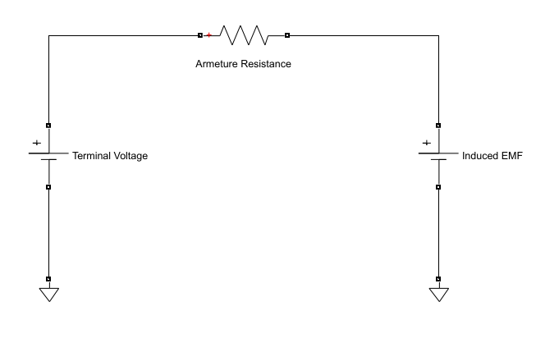

1. Find electrical power of the motor.
2. Find armature current of the motor.
3. Find induced EMF of the motor.
4. Find mechanical power of the motor.
5. Find mechanical torque of the motor.
6. Find Rotational Loss and Armature Loss of the motor.
7. What are your suggestions to control speed of the motor? Please, comment each suggestion properly.

PART B:

The setup Figure 1 is established to make a speed control of DC motor and it is called that Ward-Leonard System.

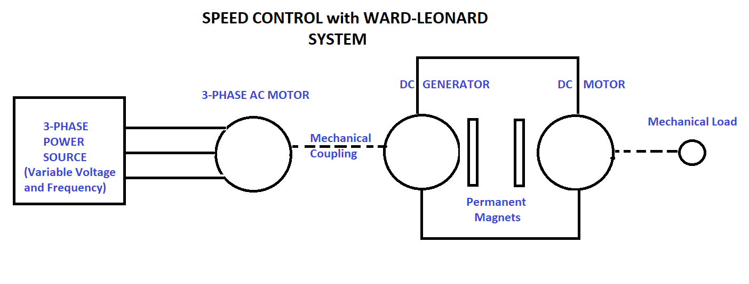

Figure 1 Ward-Leonard System

In short, DC motor are driven by the DC generator and The DC generator are rotated by 3-phase AC motor with mechanical coupling.

For the DC generator, armature resistance is 0.336 ohm. Assume that both motor and generator are operating in linear region, and rotational loss is constant. The Figure X shows circuit diagram of DC motor and generator.

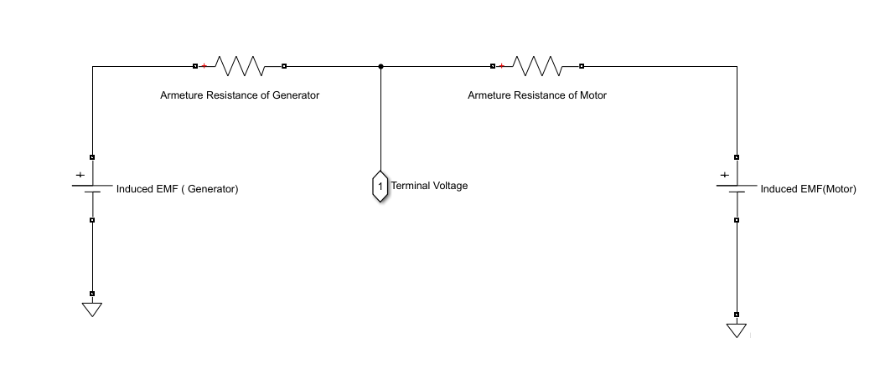

1. Determine the induced emf of generator at full load.
2. Determine the no-load speed of the motor. (The field circuits for generator and motor are the same)
3. If the DC generator is separately excited with constant field current. What must be percent of reduction in the field current of the generator to obtain no-load speed of 1025 rpm?
4. What must be induced emf in the generator if the motor supplies the same torque as in Part A but at speed of 750 rpm?
5. What is the percent change in the field current of the generator?
6. What will the motor speed under no load?

Part C

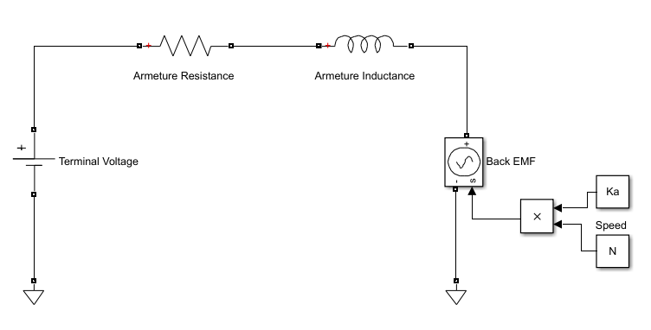

1. A dc motor started from stationary until steady state. Figure X shows the circuit schematic of the dc motor. Plot the Speed vs Time graphics to observe transient behaviour of the motor. Assume that motor is operating at linear region and rotational loss is constant. Parameters of the motor are given as:

* Part A is valid for steady state condition.
* Armature inductance is 6.6 mH.
* Inertia of the motor is 5e-2 kg-m^2.